## *** 2a iii) Based on the score, identify the best method ***

According to the scores of classifiers, K Nearest Neighbor is slightly better than Logistic Regression.

## ***2 b) Based on the optimized method identified in 2a), make prediction on test dataset and compare it with y_test dataset.***

I predicted the labels for the test data set using the K Nearest Neighbour classifier.

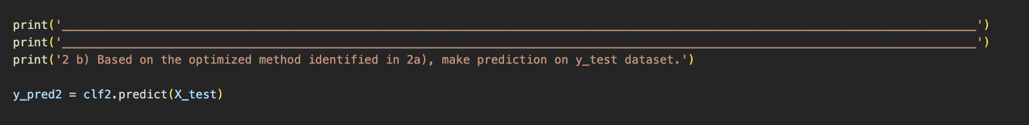

## *** 2c) Create confusion matrix with seaborn heatmap.***

## *** 2d) Evaluate the model performance.***

I calculated the accuracy score of K Nearest Neighbour classifier on y_test test set by comparing each predicted label and test label. The accuracy score of this classifier is 91.17%.

***Make a prediction based on user input (Total marks:20) ***

## *** 3a) Make a prediction/classification of the environmental condition based on the following input data: ***

Predicted class of input data: ***** var temp & humid *****

## *** 3b) From 3a), get and print the max probability of the class based on the user’s input.***

Max Probability is: 0.94